To: Jane Smith, XYZ Company  
From: Garima Singh  
Subject: December 12, 2018

This summary analyzes Colorado’s crime rate, compared to the United States and if there are specific counties of Colorado that the business should not consider putting in a location.

**EXECUTIVE SUMMARY**

**Major Findings**

The state of Colorado as a whole has less violent crime rate per 100,000 people, however has higher property crime rate per 100,000 people9. Colorado when compared to the West has lower violent crime and slightly lower property crime per 100,000 people9. When digging into property crimes in Colorado, Bribery, Extortion/Blackmail and Motor Vehicle Theft are significantly higher (at 32.76%, 13.17% and 8.86% respectively) of the entirety of the United States12. Bribery seems to be an outlier from El Paso County, and Douglas County inflates the Extortion/Blackmail number. Within violent crimes, Denver and Pueblo have the highest murder rate per 100,000 people10. However, when compared to other metropolitan cities across the United States, Denver has a low murder rate—Detroit is roughly the same size in population, but has five times as many murders11.

**Recommendations for Action**

The state of Colorado is relatively safe, as the violent crime rate per 100,000 people is lower in Colorado than when compared to the United States as a whole9. While the property crime rate (per 100,000 people) is higher in Colorado than the United States, it is not significant enough to eliminate Colorado as a business location. In a nod to the law of large numbers, this analysis has confirmed the larger the population, the higher likelihood of crime. Thus metropolitan counties, whom have a higher consumer base for the business, also correlate to a higher likelihood of crime. Thus, when evaluating crime at the new potential location for the business, Colorado is a safe place to put a location, and as long as it is kept in mind that the larger the population, the larger likelihood for crime, there are not particular counties to avoid.

**Analytical Overview**

Multiple data sets were used to analyze this question. To find city crime comparison numbers, we utilized CityRating.com, while *Go Code Colorado* provided multiple data sets regarding county measurements such as voter information, medical marijuana patient, labor force and unemployment rate. It is important to note that while the Go Code Colorado data sets were beneficial, they required a lot of manipulation, as the datasets were inconsistent with their county names, and their numbers were inconsistent in format. The crime statistics for Colorado and its counties came from *FBI Crime Statistics*.

This project required more time than anticipated cleaning the data to make it usable for our data analysis. Within R and Excel, invalid and non-numeric rows were removed and relevant data columns were consistently formatted. The goal of the regression was to find total offenses by county. The stepwise regression model was used, with the first and most effective model showing the total number of unemployed individuals in the county, followed by the number of medical marijuana patients, median income and home foreclosures. The adjusted r2 was .86253, however that conclusion could also be derived from understanding that the larger the population, the higher the likelihood for higher crime numbers. The log of total offenses was taken to scale the data. With this transformation and seven variables factored in, the resulting adjusted r2 was .64544. After this result, more data was scaled – all non-ratio, percentage or median values were divided by the total population to standardize these variables into a ratio. With this transformation of variables, whether the county was metropolitan or not performed as the highest indicator, with an r2 of .4895, then followed by the medical marijuana patient ratio. These two variables had an adjusted r2 of only .5542. When the two variables were paired with transformed offense data, the result was an even less desirable effect. In conclusion, population factors are the primary predictor of the number of crimes—as no other variables were found to be significant.

**GRAPHS AND CHARTS**

1. 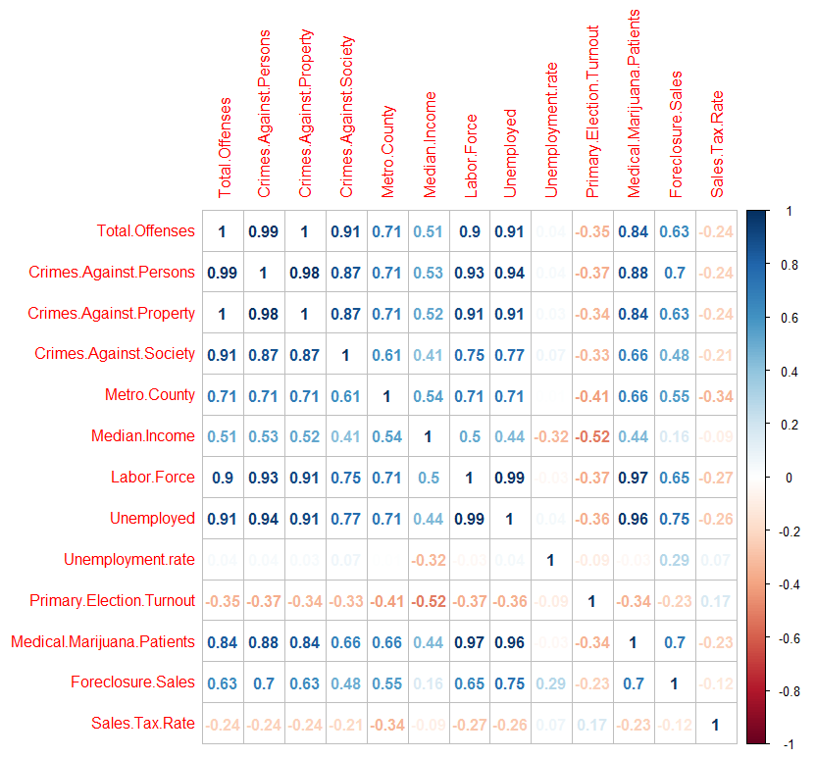

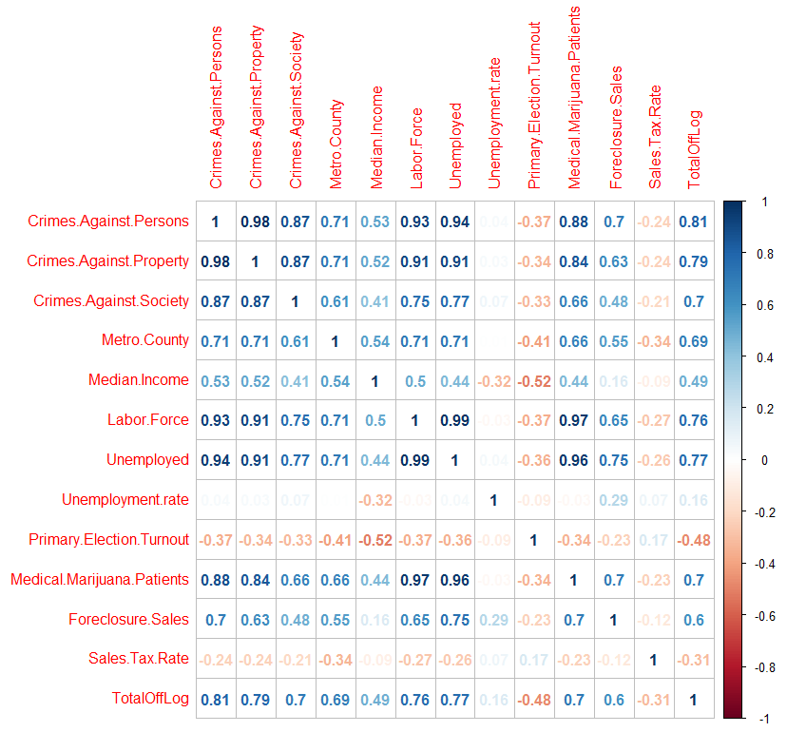

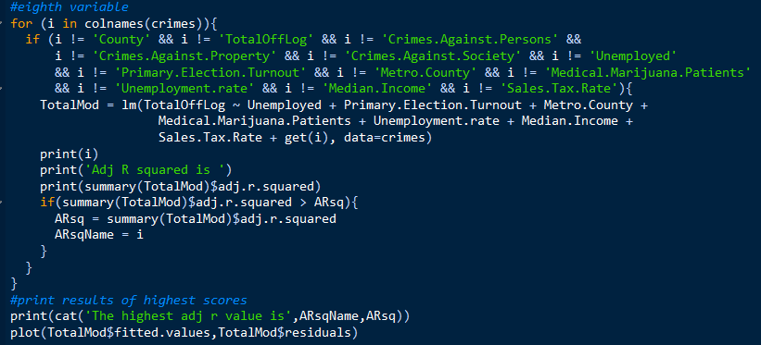

2. 
3. 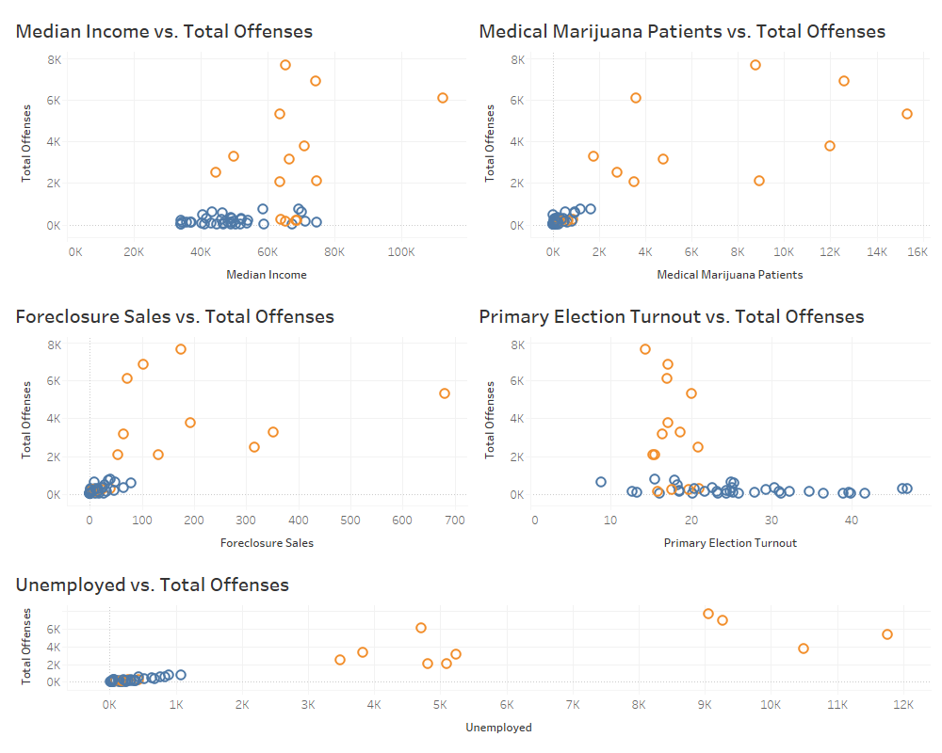

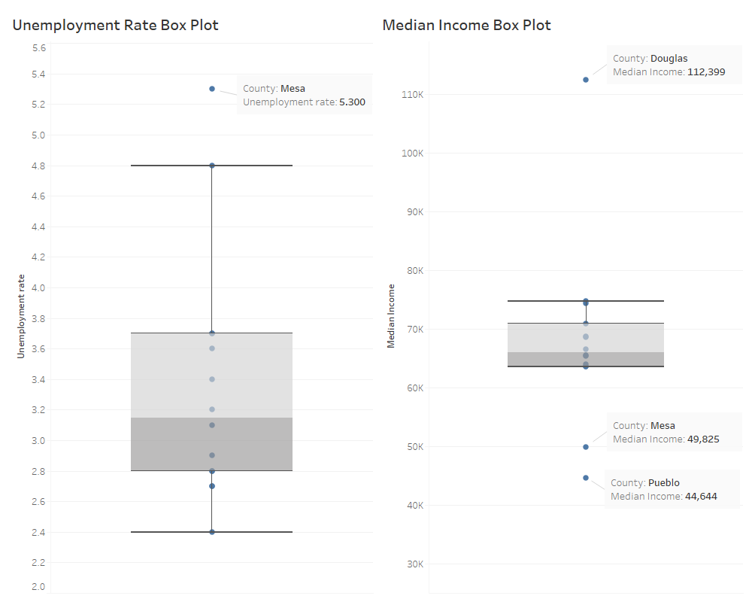

1. 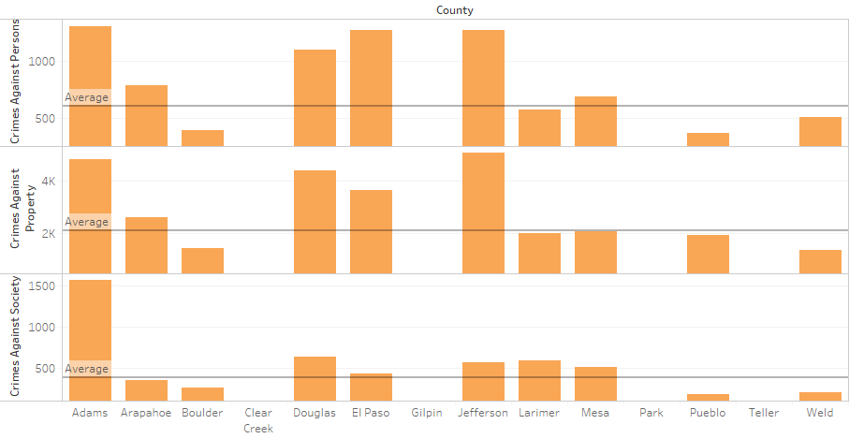

|  |  |  |  |
| --- | --- | --- | --- |
|  | **Crimes Against Persons** | **Crimes Against Property** | **Crimes Against Society** |
| Colorado | 57,498 | 234,678 | 36,993 |
| United States | 1,387,478 | 3,811,257 | 902,299 |
| Percentage | 4.14% | 6.16% | 4.10% |

|  |  |  |
| --- | --- | --- |
|  | Violent Crime | Property Crime |
| Colorado | 344.1 | 2,751.20 |
| West | 417.5 | 2,769.7 |
| USA | 397.5 | 2,451.6 |

1. 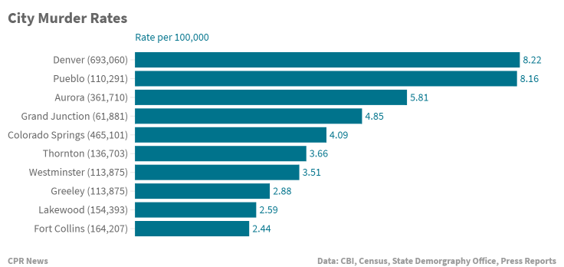
2. 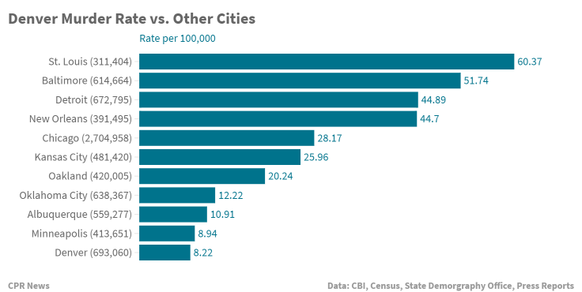
3. 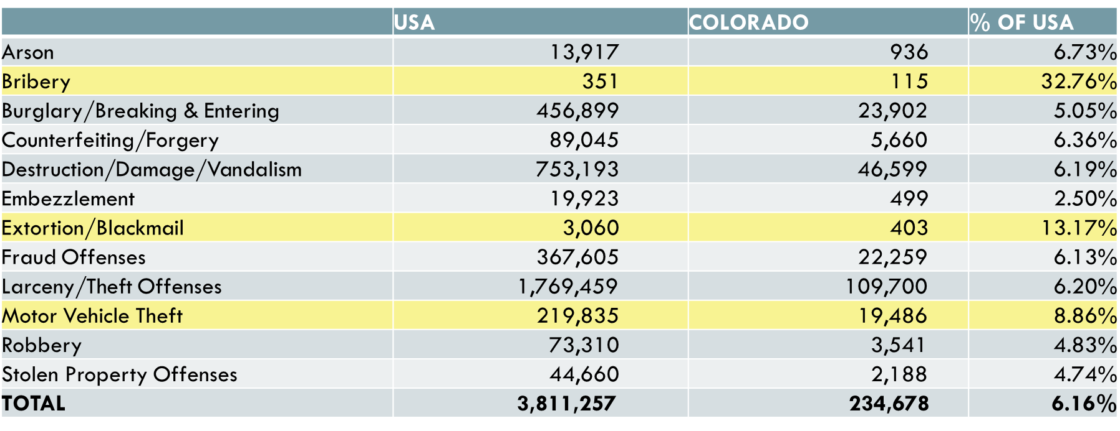
4. 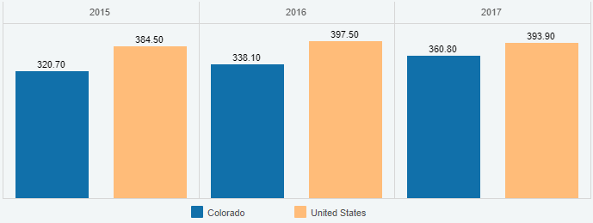
5. 